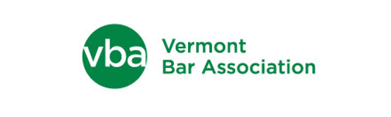

V B A C I V I C S AW A R D

The Vermont Bar Association announces its first annual VBA Civics Award, open to all Vermont high school students.

The award is designed to encourage and reward civics education and the understanding and appreciation of the rights and obligations of citizenship in our democracy. The winners will be chosen based on their demonstrated achievement of these goals, including:

- Level of knowledge in civics topics (e.g., branches of government, history and principles of our democracy, the legal system)
- Civics skills (e.g., critical thinking, respect for other points of view, identifying issues of public concern), and
- Engagement with the community (e.g., organizing and participating in community civics efforts or community service projects with a civics theme, coordinating community outreach and education regarding civics topics, communicating through letter writing and other forms of public engagement, encouraging participation in democratic processes and exercises – including how civics knowledge and skills were applied in the community engagement).

There will be two categories of submissions: (1) classroom (teacher and students), and (2) individual student. Submissions should consist of a written description of the classroom or individual project, not to exceed 600 words. The submission may also include an 11 x 14 poster that includes original photographs or drawings that illustrate how the project was implemented. Submissions will be judged on the degree to which the project meets all three of the above-stated goals, as well as on creativity, accuracy and neatness.

Prizes will include a cash award of $300 to the classroom winner and a cash award of $150 to the individual student winner. Plaques will also be presented for both categories during the awardees’ school awards ceremonies.

Please address submissions to the VBA, P.O. Box 100, Montpelier VT 05601-0100 and postmarked on or before May 7, 2022 or hand-delivered to the VBA Office at 35-37 Court Street, Montpelier VT 05601-0100, by 4:30 p.m. on May 7, 2022. If you have any questions about this contest, please contact the Vermont Bar Association at 802-223-2020 or e-mail info@vtbar.org with “Civics Award” in the subject line. Thank you and good luck!

